**Chainbridge Medical Partnership**

REGISTRATION QUESTIONNAIRE FOR PATIENTS OVER 16 YEARS

E-Mail Address (this will be used to set up your on-line access to book appointments and order any medication you take)

………………………………………………………………………………………………………………………………………………………………………

What is your height? ………………………………………What is your current weight? ………………………………………………

What is your first spoken language (e.g. English) …………………………………………………………………………………………

Do you require an interpreter when attending an appointment? .....................................................................

What is your ethnicity (e.g. White British) …………………………………………………………………………………………………….

Are you a Veteran? (ex-service person)…………………………………………………………………………………………………………

Do you have a Partner or Child who is a Veteran? Who? ………………………………………………………………………………

Do you smoke? If yes how many, approximately, do you smoke per day? …………………………………………………….

Are you a carer? (A carer is someone who, without payment, gives help and support to a person who otherwise may not manage because of their disability, frailty, or illness)

If yes who do you care for? ……………………………….……………………………………………

Do you have any communication needs that the practice should be aware of (e.g. sight or hearing

problems)?…………………………………………………………………………………………………………………………………………………….

Do you have any long term conditions (e.g. Asthma, COPD, Heart conditions, diabetes)?……………………………..

………………………………………………………………………………………………………………………………………………………………………

If you are on regular medication you will need to tell us which pharmacy you want this to go to when it is due. The practice does not produce paper prescriptions as we operate a fully computerised system.

Name of pharmacy………………………………………………………………………………………………………………………………………..

**Your NHS Data Matters**

Information about your health and care helps the NHS improve your individual care, speed up diagnosis, plan your local services and research new treatments.

In May 2018, the strict rules about how this data can and cannot be used were strengthened. The NHS is committed to keeping patient information safe and always being clear about how it is used.

You can choose whether your confidential patient information is used for research and planning.

To find out more or to opt-out you must go to the follow website otherwise your information will automatically be entered.

[**www.nhs.uk/your-nhs-data-matters**](http://www.nhs.uk/your-nhs-data-matters)



…and each of these is more than one unit

This is one unit

of alcohol…



|  |  |  |  |  |  |  |
| --- | --- | --- | --- | --- | --- | --- |
| **AUDIT** | **Scoring system** | | | | | **Your score** |
| **0** | **1** | **2** | **3** | **4** |
| How often do you have a drink containing alcohol? | Never | Monthly  or less | 2 - 4 times per month | 2 - 3 times per week | 4+ times per week |  |
| How many units of alcohol do you drink on a typical day when you are drinking? | 1 -2 | 3 - 4 | 5 – 6 | 7 - 9 | 10+ |  |
| How often have you had 6 or more units if female, or 8 or more if male, on a single occasion in the last year? | Never | Less than monthly | Monthly | Weekly | Daily or almost daily |  |
| How often during the last year have you found that you were not able to stop drinking once you had started? | Never | Less than monthly | Monthly | Weekly | Daily or almost daily |  |
| How often during the last year have you failed to do what was normally expected from you because of your drinking? | Never | Less than monthly | Monthly | Weekly | Daily or almost daily |  |
| How often during the last year have you needed an alcoholic drink in the morning to get yourself going after a heavy drinking session? | Never | Less than monthly | Monthly | Weekly | Daily or almost daily |  |
| How often during the last year have you had a feeling of guilt or remorse after drinking? | Never | Less than monthly | Monthly | Weekly | Daily or almost daily |  |
| How often during the last year have you been unable to remember what happened the night before because you had been drinking? | Never | Less than monthly | Monthly | Weekly | Daily or almost daily |  |
| Have you or somebody else been injured as a result of your drinking? | No |  | Yes, but not in the last year |  | Yes, during the last year |  |
| Has a relative or friend, doctor or other health worker been concerned about your drinking or suggested that you cut down? | No |  | Yes, but not in the last year  **SCORE** |  | Yes, during the last year |  |

**Scoring:** 0–7 = Lower risk, 8–15 = Increasing risk, 16–19 = Higher risk,

20+ = Possible dependence

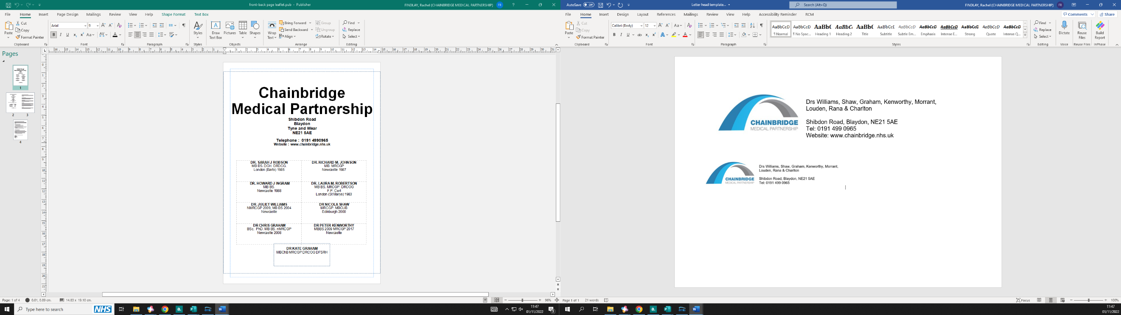

**Practice Leaflet**

Welcome to our Practice. We provide many services to help you manage your health. We work very closely with our allied community nursing, and health visiting teams. Our aim is to provide an effective, efficient and fair health care service to all our patients by:

* Putting our patients at the centre of what we do.
* Having a professional integrated primary healthcare team who are suitably qualified and trained.
* Offering our services in a safe, supportive and suitably equipped environment.

We are part of the Gateshead Inner West Primary Care Network.

**SURGERY OPENING TIMES**

**The practice is open during the following times:**

|  |  |
| --- | --- |
| Monday | 8am to 7:30pm |
| Tuesday | 8am to 6pm |
| Wednesday | 8am to 6pm |
| Thursday | 8am to 7:30pm |
| Friday | 8am to 6pm |

We operate morning, afternoon and evening surgeries from Monday to Friday. You are able to book an appointment with a doctor or nurse up to 1 month in advance. If you need an appointment for that day there will be some appointments available from 8am in the morning. These can be made either by telephone or online.

The reception staff may also offer you an appointment to go along to the Blaydon Hub. This is a service which all of Gateshead practices can use for patients with certain conditions. The receptionist will advise you about this.

**SERVICES OFFERED BY THE PRACTICE**

Below is a list of services we can offer to you. If there is anything that does not appear, please ask at reception as we will try to accommodate you if we possibly can.

|  |  |  |
| --- | --- | --- |
| Asthma Reviews | C.O.P.D reviews | Heart Failure Reviews |
| Coronary Heart Disease Review | Diabetic Nurse-Led Clinic | Minor Surgery |
| Ante-natal Clinic | NHS Health Checks | Under 5’s Immunisation Clinic |
| Contraception (Including coil removal, contraception implants and injectable Contraception) | Travel Vaccinations and Advice | Dressings |
| Urine Testing | Removal of Stitches | Advice on diet |
| Cervical Smears | Flu, Pneumonia and Shingles Vaccinations | Blood Pressure Checks Blood Testing |

**THE STAFF AT CHAINBRIDGE**

**GPs**

|  |  |  |
| --- | --- | --- |
| Dr Juliet Williams | Dr Nicola Shaw | Dr Chris Graham |
| Dr Peter Kenworthy | Dr Ian Morrant | Dr Sarah Louden |
| Dr Hemant Rana | Dr Rebecca Charlton | Dr Kate Graham |

**Practice Nurses**

Practice Nurses are fully trained in a wide range of skills including immunisations, health promotion, contraception, and management of long-term conditions eg advises on diet and lifestyle choices, on coronary heart disease, hypertension, asthma, diabetes, smoking cessation and obesity. Practice Nurses can extend their skills at Diploma Level and see many patients who previously would have seen the doctor. The Nursing team run various nurse led clinics for diabetes, asthma, coronary heart disease, COPD as well as providing general nursing services, dressings, removal of sutures and blood tests.

|  |  |  |  |
| --- | --- | --- | --- |
| Susan Wilkinson | Rachael Park | Mary Dent | Rachel Wharton |

**Healthcare Assistants**

Non-registered nursing staff who assist in patient care and Practice-related duties as directed by and under the supervision of a Registered Healthcare Professional (including Lead Practice Nurse, Practice Manager, and the GPs). Healthcare Support Workers work collaboratively with the General Practice team to meet the needs of patients, and provide essential task-orientated services like taking blood samples (phlebotomy), processing specimens, performing ECGs (to measure heart function), spirometry (to measure lung function). They play a crucial role in supporting the Clinical Team.

|  |  |  |
| --- | --- | --- |
| Gemma Cuthbertson | Kelly Wanless | Emma Laws |

**Management**

Debbie is involved in managing all of the business aspects of the Practice such as making sure that the right systems and people are in place, at the right time, in order to provide a high quality of patient care, human resources, finance, patient safety, premises, equipment, and information technology. She supports the admin team, GPs and other medical professionals with delivering patient services and also helps to develop extended services to enhance patient experience and care. She is assisted in her role by Debbie Hilling.

|  |  |
| --- | --- |
| **Practice Manager**  Debbie Calder | **Assistant Practice Manager**  Debbie Hilling |

**GP assistant and Systems and Information Manager**

Katherine is responsible for the Practice computer systems and other Practice systems that we use, to assist us, in delivering patient care.

|  |
| --- |
| Katherine Davison |

**Secretaries**

The secretarial staff support the team in producing both clinical and non-clinical referral letters and any reports/letters that have been dictated by the Doctors. They process any subject access requests involving copies of medical records.

|  |  |
| --- | --- |
| Rachel | Leonie |

**Reception:**

These members of staff attend to patients on the phone and in person. They co-ordinate and organise appointments and documentation to facilitate the smooth running of the Practice and support delivery of quality patient care. These staff have a very demanding role. They are here to assist you. We would ask you to be patient during peak times when the staff can handle a large volume of calls and enquiries. They will ask you a small amount of personal information about your medical condition – this information is used to ensure your call is dealt with by the correct clinician and assist fellow healthcare professionals who work within the Practice, in managing your health care and well-being. All staff adhere to the Practice’s confidentiality policy and Data Protection Act 2018.

|  |  |  |  |  |  |
| --- | --- | --- | --- | --- | --- |
| Selina  Office Lead | Kelly | Emily | Carol | Allison | |
| Leonie | Amy | Sharon | Gemma | Alice | Charlotte |

**Cleaners**

|  |  |
| --- | --- |
| Linda | Bethany |

**PRACTICE AREA**

The practice area covers Blaydon, Ryton, Winlaton, Winlaton Mill, Swalwell, Lockhaugh, Crookhill, Stella, Stargate and Blaydon Burn. Please see the Practice Boundary Map to see the exact areas covered by Chainbridge Medical Partnership

If you move locally, or change any of your details, please inform reception. It is also very helpful to have an up to date telephone number.

If you move out of the practice area, you will need to re-register with another practice within your new area.

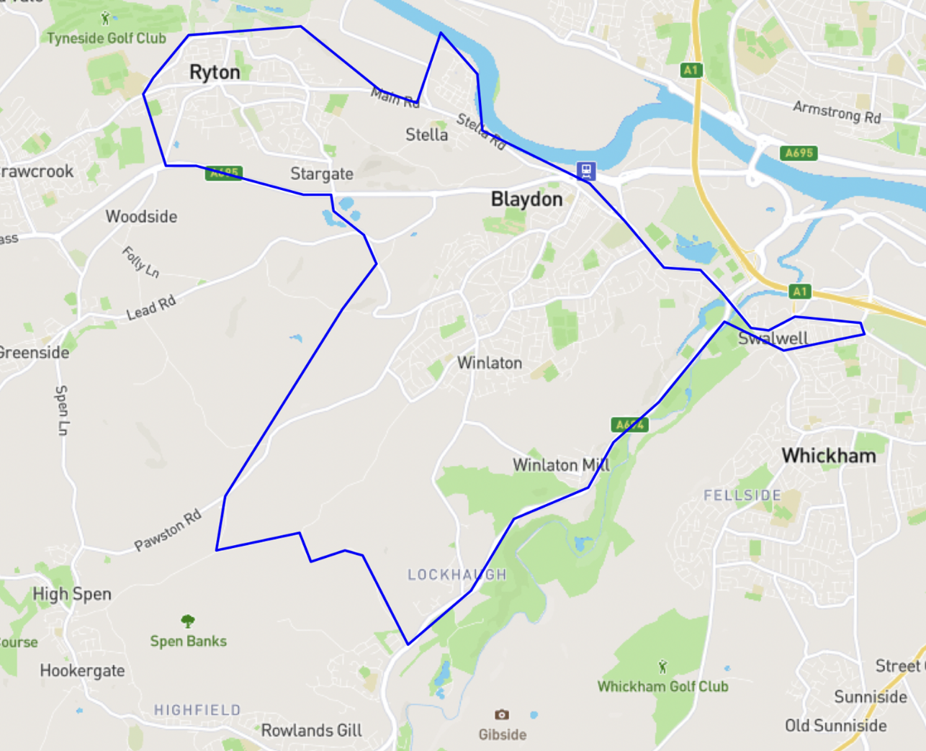

**REGISTERING AT THE PRACTICE**

To register with the practice, simply visit our practice website: <https://www.chainbridge.nhs.uk/new-patients-2> or ask at reception. You will be given a form and questionnaire to complete and will need to supply 2 forms ID, one for proof of address and the other photographic ID.

When you require a GP appointment you are entitled to request to be seen by the G.P of your choice.

**ACCESSIBILITY TO PATIENTS**

Chainbridge Medical Partnership is a modern, purpose-built surgery and has facilities for all disabled patients. The bus station is a short distance away over a flat, even surface.

**HOME VISITS**

Our doctors typically see four patients at the practice in the time it takes to do a single home visit. For this reason, we ask our patients to come to the practice if at all possible. However, we can visit you at home if your condition means you cannot attend the practice. Please ring the surgery before 10:30 am to arrange a visit. Please be prepared to tell the receptionist about your condition so we can visit the most urgent cases first. The doctor may wish to speak with you to see if it would be better for you to come to the surgery to be seen immediately.

Home visits are normally made following morning surgery.

**IF YOU NEED A GP OUT OF HOURS**

If you need to see a doctor urgently when the surgery is closed please telephone 111 directly or the surgery on 0191 4990965 and you will be put through to 111 who will take your details and decide on the best course of action. If appropriate they will pass a message to the doctor on duty who may phone you to assess your problem. You might be asked to attend the out-of-hours clinic, or receive a home visit.

**NHS 111**

 You can phone NHS 111 on 111. NHS 111 offers free expert health information and advice 24 hours a day. It can advise you whether you need to go to the nearest A&E (accident & emergency) or if there is an alternative such as visiting an NHS walk-in Centre.

**Local Walk-in Centres**

You are able to attend an NHS walk-in Centre which provide advice and treatment for a range of minor illnesses & injuries.

 The nearest Walk-in Centres include:

* Gateshead walk-in Centre, Queen Elizabeth Hospital, Sheriff Hill, NE9 6SX
* Newcastle walk-in Centre, Newcastle General Hospital, Westgate Road, Newcastle, NE4 6BE
* Blaydon walk-in Centre, Shibdon Road, Blaydon, NE21 5NW

**PRESCRIPTIONS**

Repeat prescriptions are computerised. There are 3 ways of ordering your repeat Prescriptions:

· Online—you will need to register with the practice for this service

· At the surgery by posting your order form in the box in reception

· Via the surgery letter box situated on the outside of the building

 Once you have ordered your prescription you will need to let us know which pharmacy you want your prescription to be sent to and it will be sent directly to them. Please be aware items not on your repeat prescription list will take longer or may not be prescribed without an appointment.

**ONLINE SERVICES**

* The surgery is now able to provide the following services online:
* Booking/Cancelling appointments
* Ordering repeat Prescriptions
* Viewing your medical records

 To be able to access this service please visit our practice website (<https://www.chainbridge.nhs.uk/edit/online-services-2>) or call into the surgery with photographic ID and the receptionist will print off your ID numbers and the website to go onto. From there you would follow the on-screen prompts to create an account.

 Once this has been arranged you can access any of the online services.

**PATIENT FORUM**

 The practice has a Patient Participation Group where current practice issues are discussed and if you are interested in joining please ask at reception for further details.

**E-CONSULTATIONS**

E-Consultations provides online medical advice at the click of a button on our practice website. You will be able to learn more about your condition and contact your GP via a form to seek advice. This will allow the GP to decide on the most appropriate treatment options for you and you will receive a response by the end of the next working day. You can also request sick notes/medical appointments as well as many other services.

**ASKING FOR ADVICE AT THE SURGERY**

Doctors and Nursing staff are available to give advice over the telephone, but if they are busy at the time you ring, they will ring you back at their earliest convenience.

**TEACHING AND TRAINING**

The practice is a teaching practice and will regularly have Trainee Doctors, Student doctors, Student Nurses and Pharmacy Students observing their clinic. Please tell the receptionist if you prefer to be seen alone.

**ABUSIVE PATIENTS**

This practice does not tolerate abusive language or threatening behavior towards staff or other patients, and any patient behaving in a threatening or violent manner will be removed from our practice list.

**SUGGESTIONS**

 Everyone in the Practice is committed to giving the patients the best possible care and service. If you have any worries or complaints – TELL US – we cannot put things right if we do not know that you are dissatisfied.

We would be interested to hear any suggestions you may have for improving the existing service, and also ideas you may have for new services. There is a suggestions box situated in the entrance porch to post your views.

**COMPLAINTS**

 We strive to offer a high quality of service to our patients but if you have any queries or complaints, please contact Debbie Calder (Practice Manager). A complaints pack can alternatively be obtained from reception.

**DATA PROTECTION ACT 1998 – INFORMATION FOR PATIENTS**

Information about you is recorded in your medical record and is protected by the Data Protection Act 1998. Sometimes this information is required by hospitals and other healthcare staff in order to ensure that you receive the appropriate treatment.

**OUR RESPONSIBILITY TO PATIENTS**

* Respect and courtesy will be extended to you at all times.
* You have the right to confidentiality.
* You will be treated with skill and consideration and receive care to a high quality.
* Doctors and nurses will endeavour to see you on time.
* You will be informed if there is a delay of more than 20 minutes from the time of your appointment.
* Your suggestions and complaints will be dealt with promptly.

**RESPONSIBILITY OF PATIENTS**

* You are asked to extend courtesy and respect to all members of staff.
* You are responsible for keeping your appointment or, if you wish to cancel, giving adequate notice in order that the appointment may be made available to someone else.
* Night visits should only be requested if they are absolutely necessary.
* You are reminded that your health and lifestyle are your responsibility.
* You should make all efforts to attend the surgery.

The Practice currently works under an NHS contract with:

NHS England

Waterfront 4

Goldcrest Way

Newburn Riverside

Newcastle upon Tyne

NE15 8NY

0191 5026542

THIS IS AVAILABLE IN LARGER PRINT PLEASE ASK AT RECEPTION